CK24 -

Functionality
Once you have carried out a cost estimate for a material, you can transfer the costing results to the material master as prices.
To set a new standard price in the material master, you must mark and release the standard cost estimate. Before you can mark and release a standard cost estimate, you must allow standard cost estimates to be marked and released in a company code.
If you release a standard cost estimate for a material, the marked price is transferred into the material master record as the current standard price for the current period. This price is then active for external accounting. The materials with "S" price control are valuated with the new standard price. The current standard price becomes the previous standard price. Simultaneously periodic unit price is used in single-level and multilevel material price determination to valuate the materials for the closed period.
Once you have released the cost estimate, you cannot create a new standard cost estimate in this period. Although you can delete a released cost estimate, the materials are still valuated with the released standard price. When a current standard cost estimate is deleted, the previous standard price no longer becomes the current standard price. To determine a new standard price, you have to carry out costing, marking and releasing afresh.

Scenario
Release a standard cost estimate for the material 64 – Butane -1 in the plant 1200 –The price calculated in the standard cost estimate was transferred into the material master record as the future price and now will be updated as a current standard price.

Requirements
The cost estimate has the status ‘VO: Marked without errors’. Only the results of cost estimates that have been marked without errors can be released.

Menu Path | Accounting → Controlling → Product Cost Controlling → Product Cost Planning → Material Costing → CK24 - Price Update → CK24 - Price Update
Transaction Code | CK24

1. Double click on CK24 - Price Update.

Price Update: Mark Standard Price

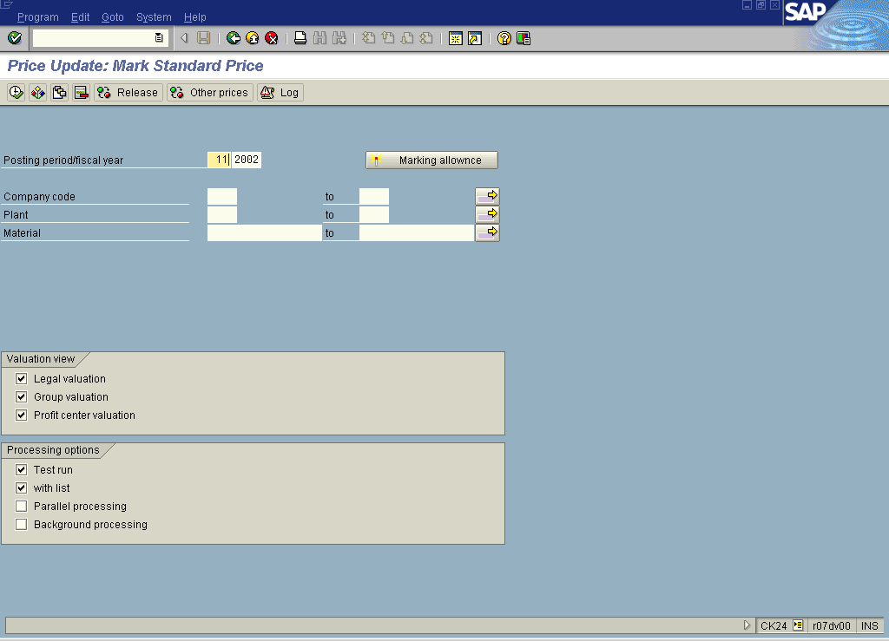

2. Click the Release button.

Price Update: Release Standard Price

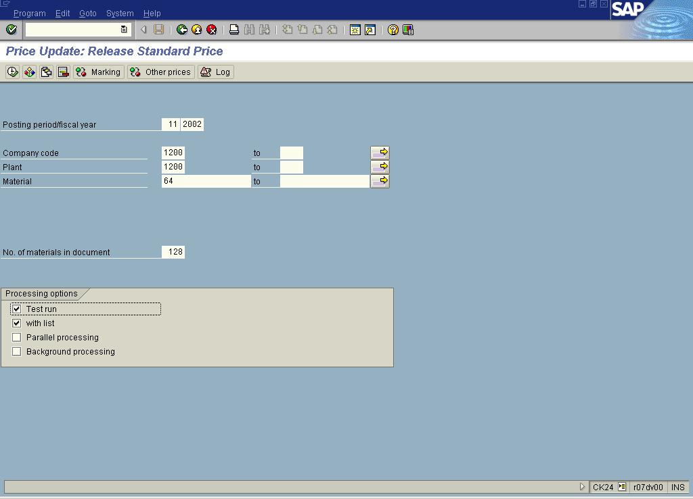

3. Update the following required and optional fields:

Field Name | Description | Values
Company code | Code identifying the company purchasing the material | Example: 1200
Plant | Code identifying the operational unit of the company where the material is manufactured and stored | Example: 1200
Material | Code identifying a product or component | Example: 64

Price Update: Release Standard Price

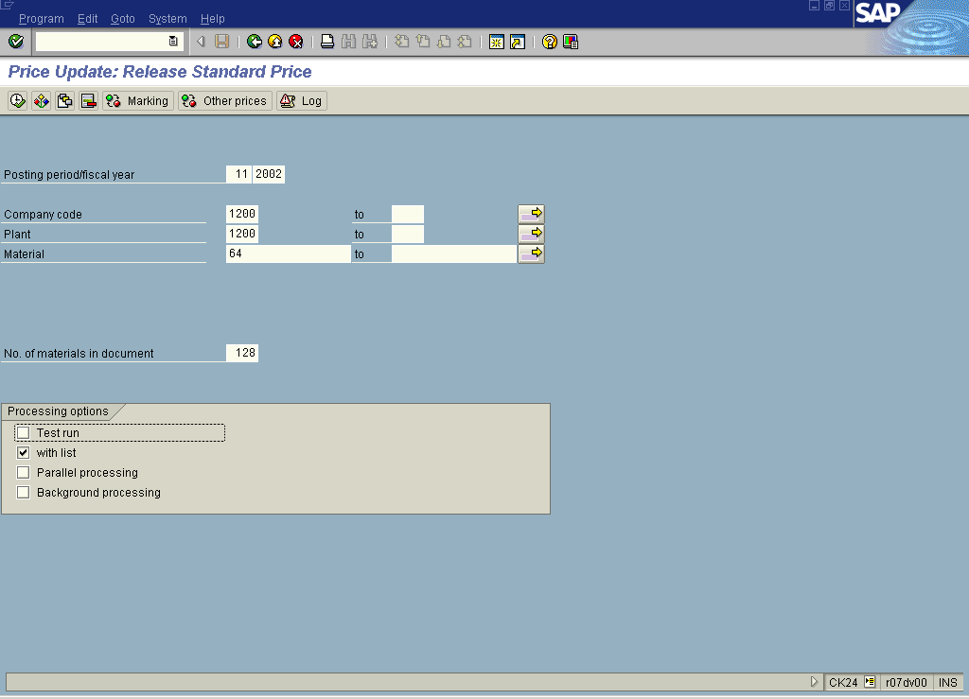

4. Click the Test run checkbox to deselect.

5. Click the Execute button.

Price Update: Release Standard Price

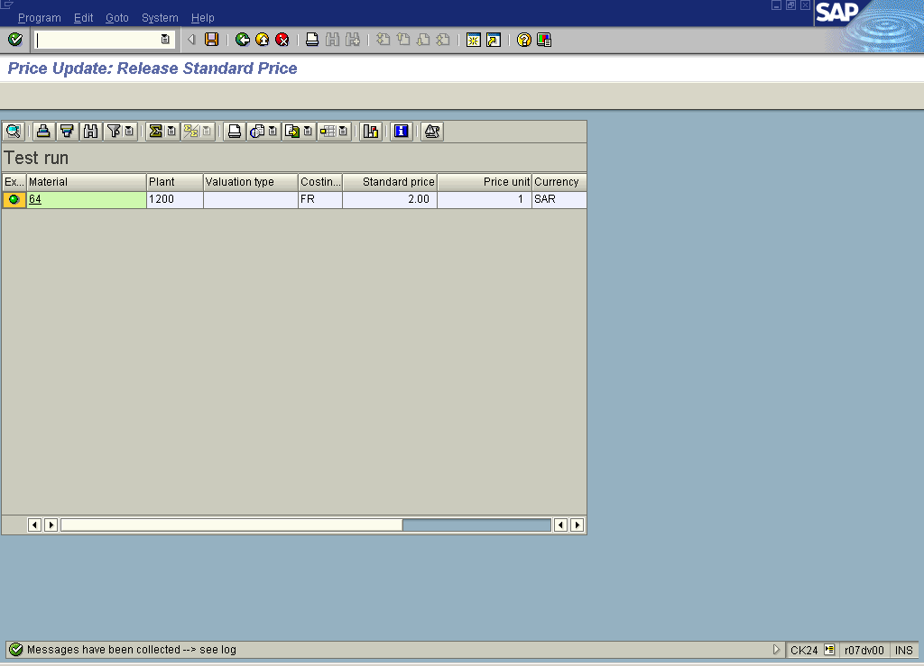

6. Click the Log button.

Price Update: Release Standard Price

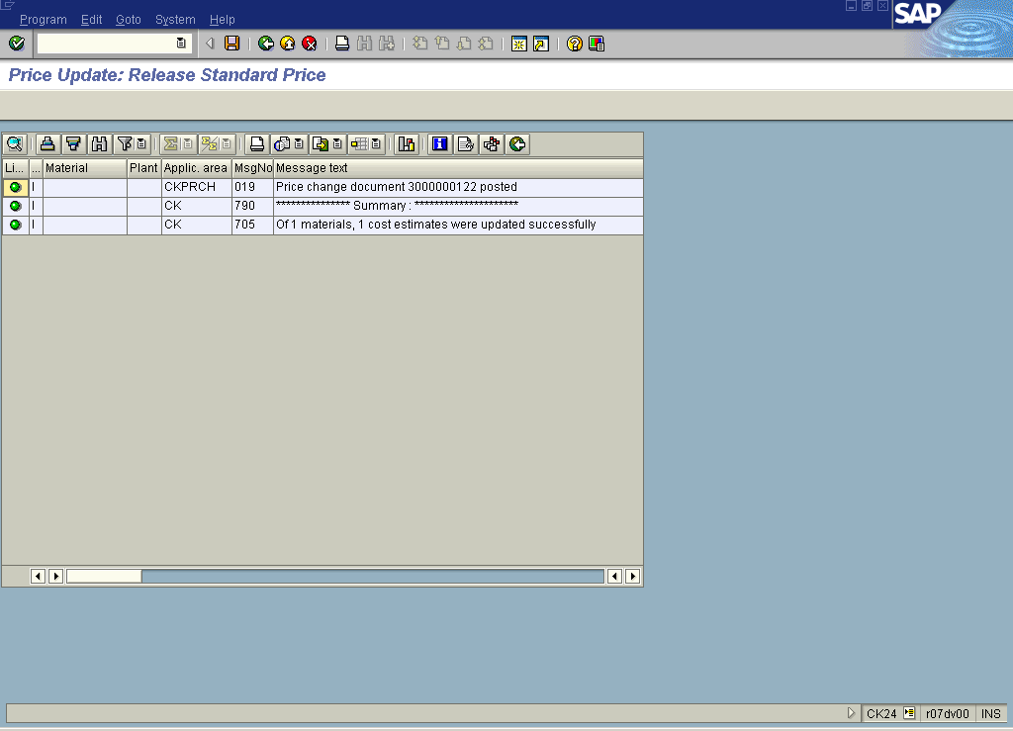

7. Click the Back button.

Price Update: Release Standard Price

8. Click the Back button to go back to SAP Easy Access screen.

